**Online Test Application**

The code for this project is hosted at <https://github.com/ShrinathGajam/Online-Test-Application-phase-4.git>

The project is developed by Shrinath Gajam.

# Outputs:

## **Flow of the Application:**

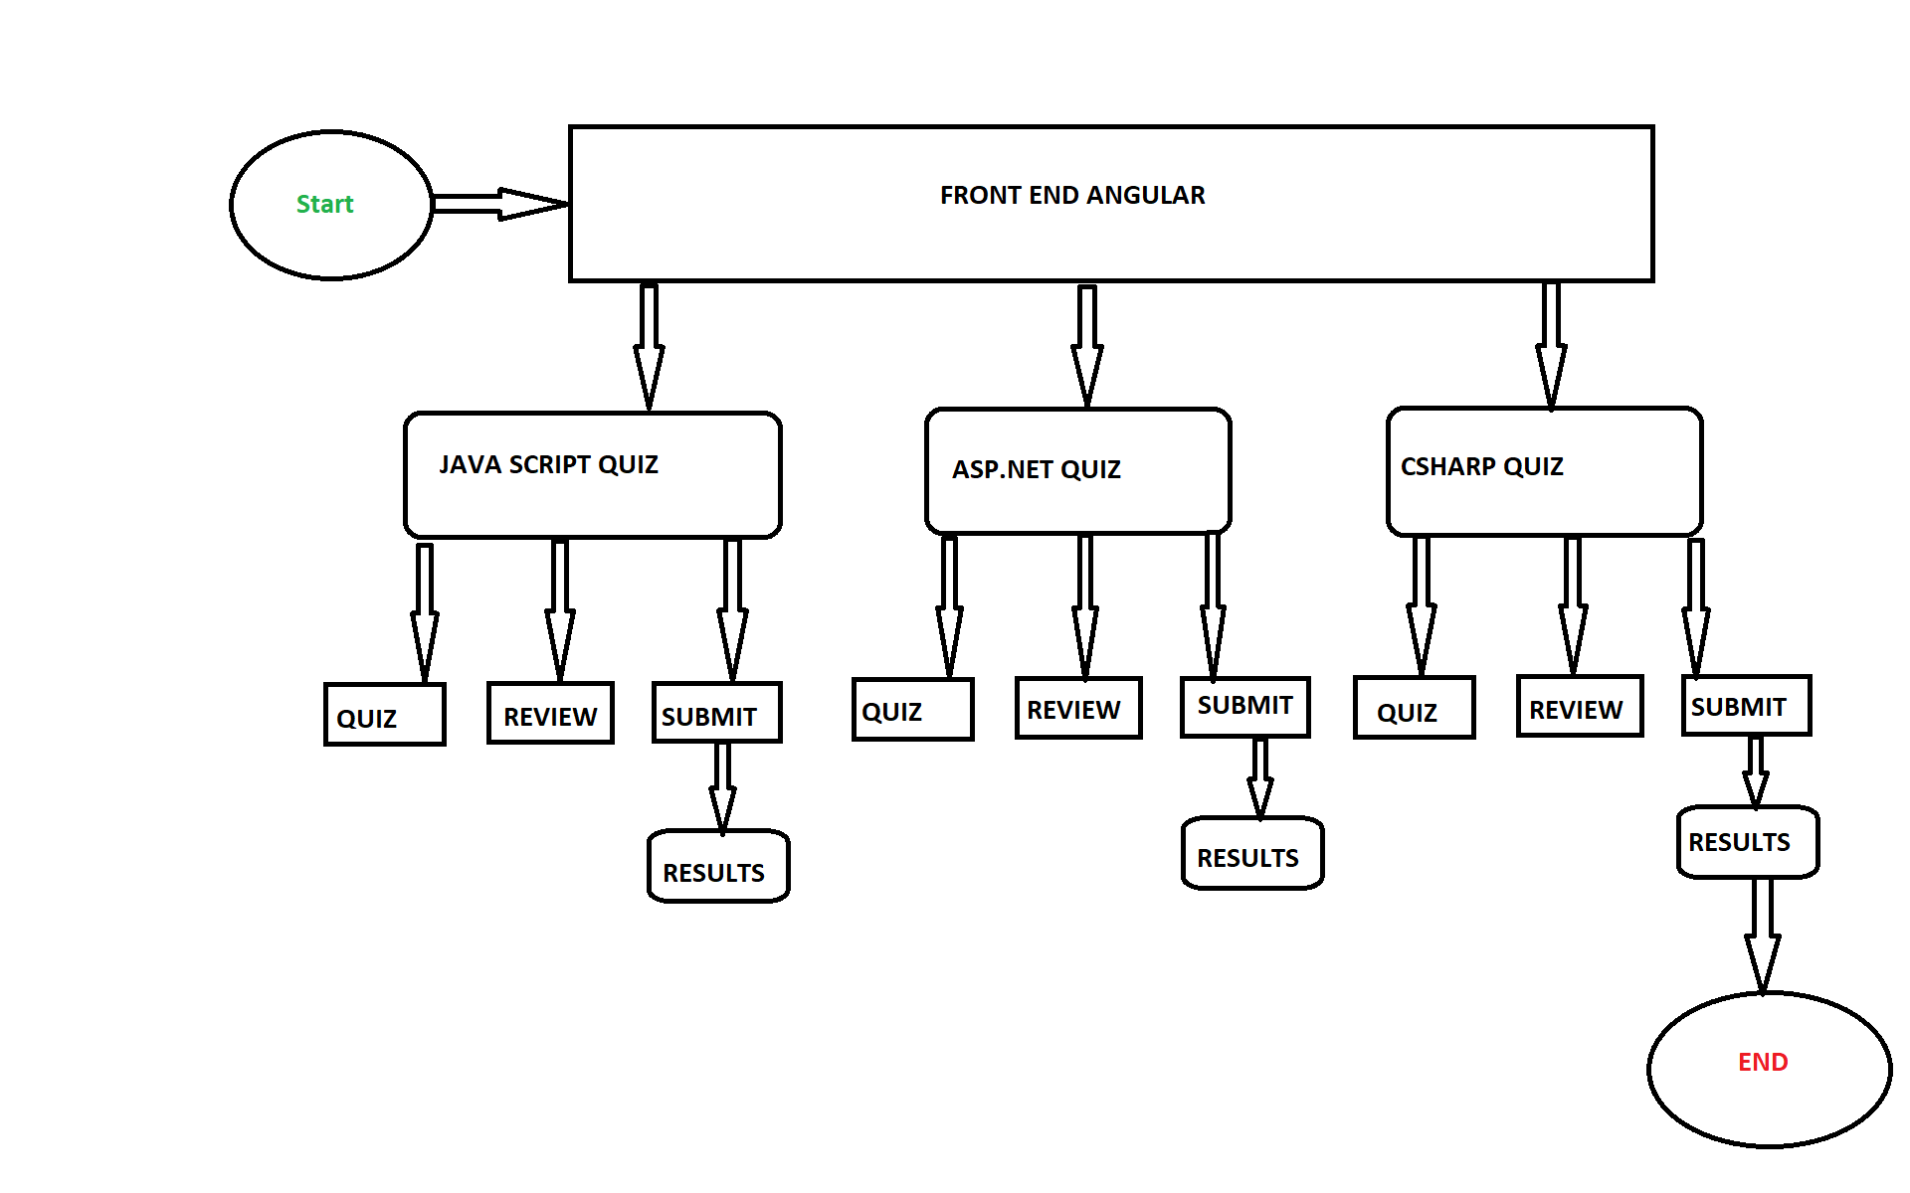

**Screenshots of all Scenarios in the Application:**

**Home Page Contains Quiz options user can take: (There are three quiz options now – Javascript, Asp.Net and C# (C Sharp)).**

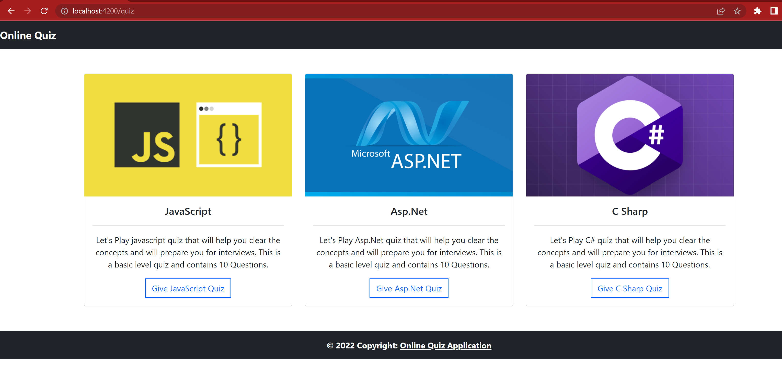

**The Quiz Names and Description are fetched dynamically using JSON data (Containing Questions and Answers) and Angular Framework.**

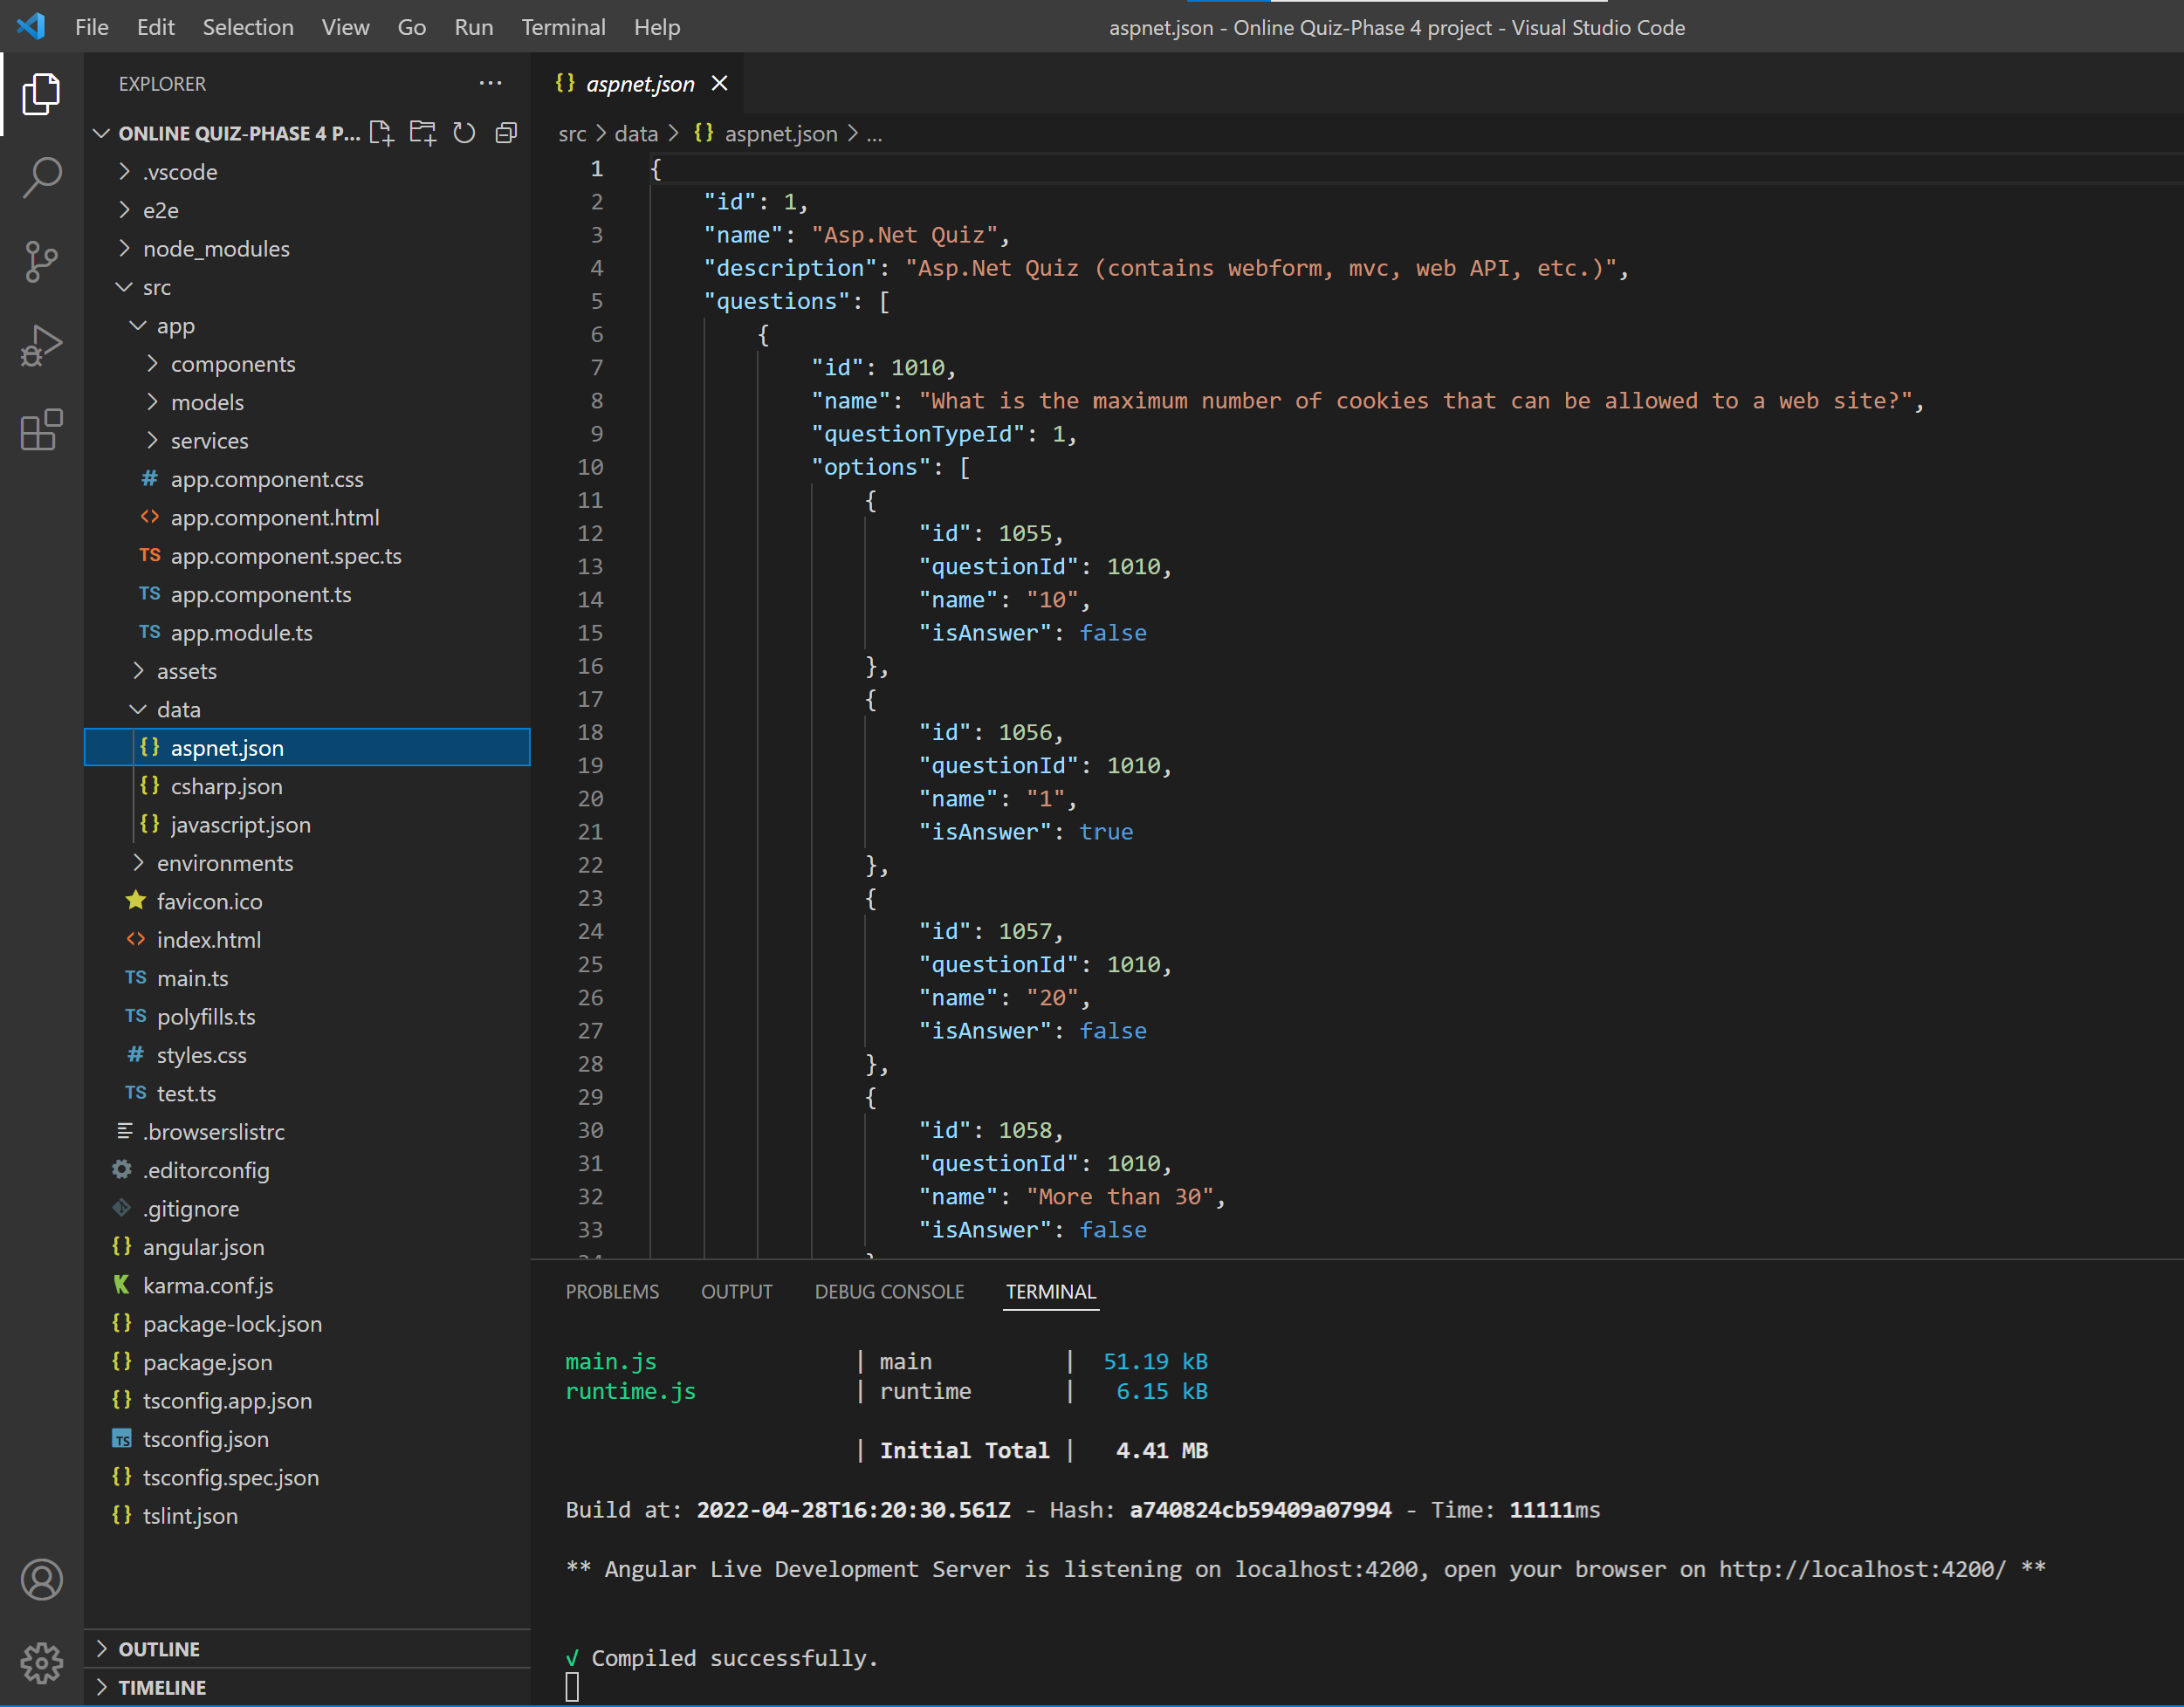

1. **When User Selects JavaScript Quiz, they are redirected to JavaScript quiz page where they can see all the questions with their options rendered from JSON file.**

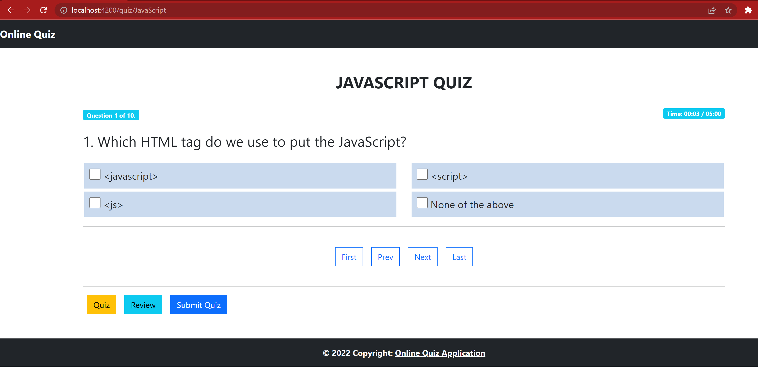

**User also have the option to navigate through questions using navigation links (First, Last , Prev and Next). There is also timer for quiz, after completion of allotted time the quiz submits automatically or User can submit their quiz before time using Submit Quiz button.**

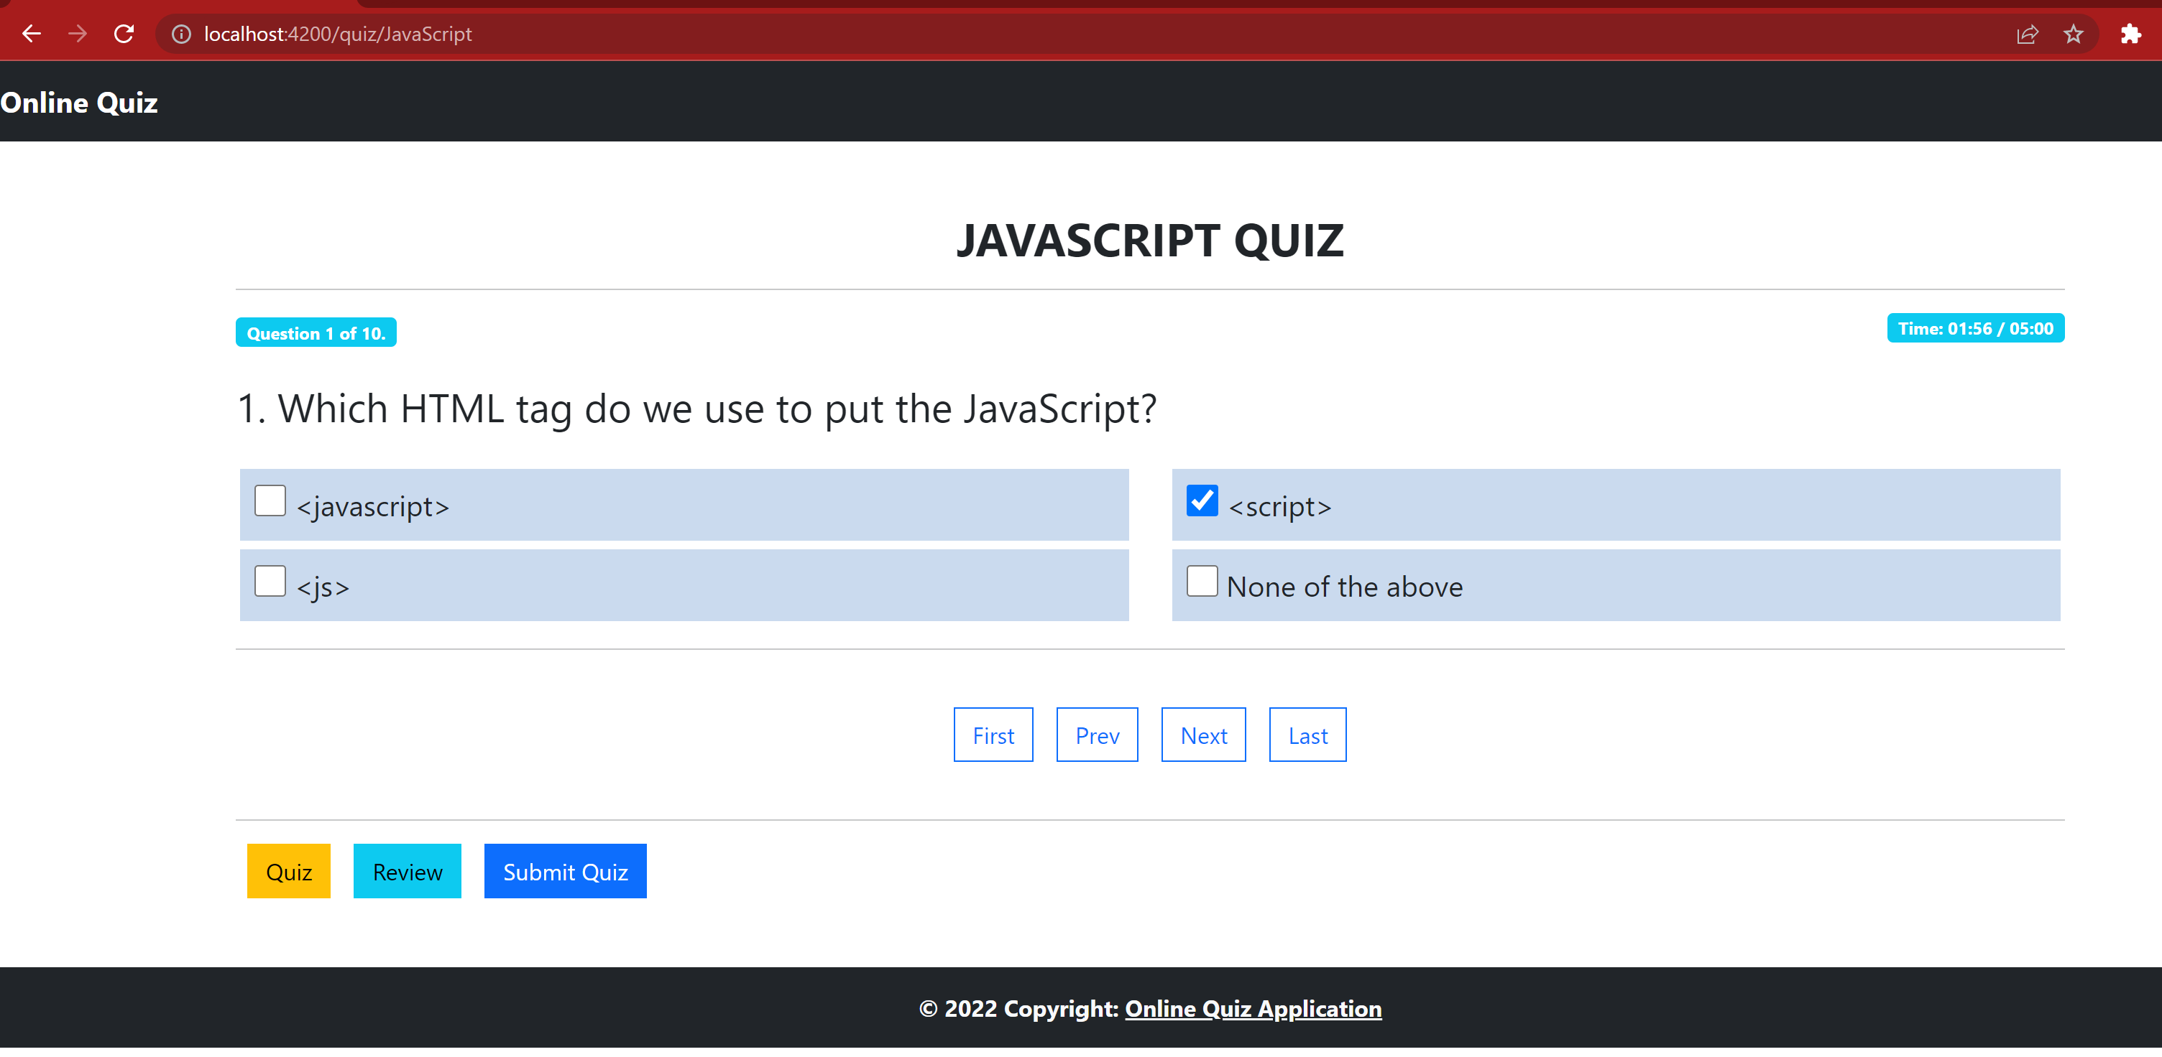

**User can select an option for the question and move to next question by clicking next navigation button**

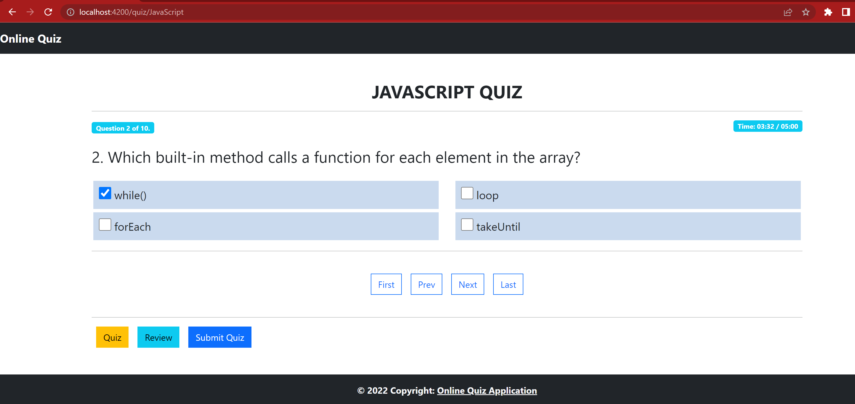

**Similarly, User can Answer all the questions asked**

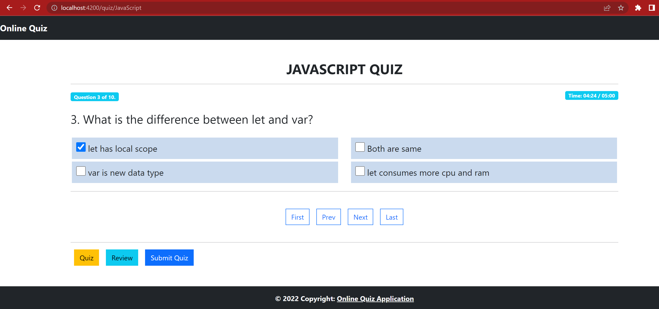

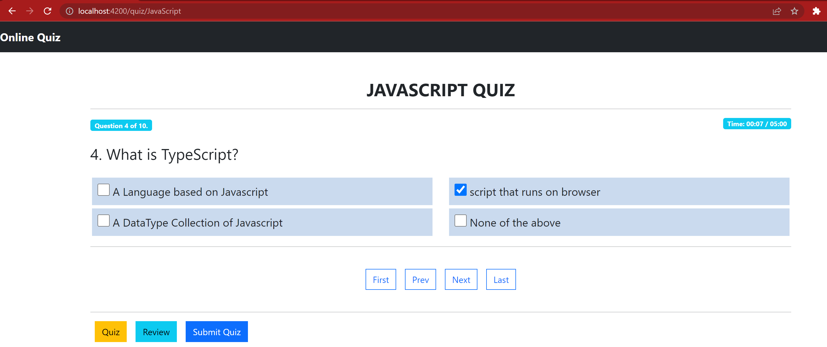

**User can also navigate to last or First question directly from First and Last Nav Links**

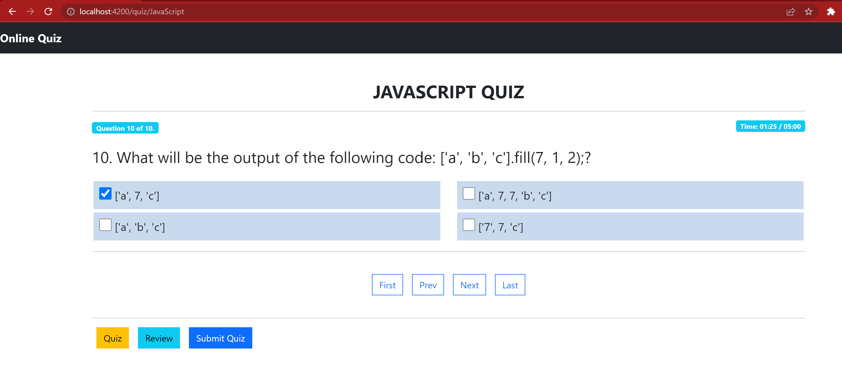

**User can Review All the Answered and Not Answered Questions by Clicking on Review Nav Link.**

**Also user can go to specific question to answer by clicking on any of the Question Blocks.**

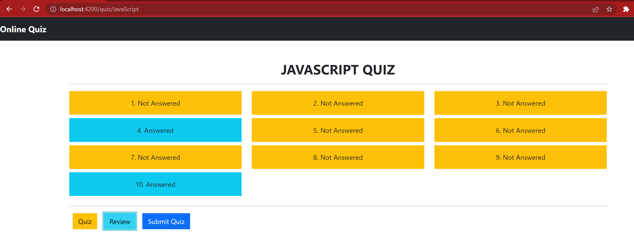

**User wanted to answer the 5th Not Answered Question:**

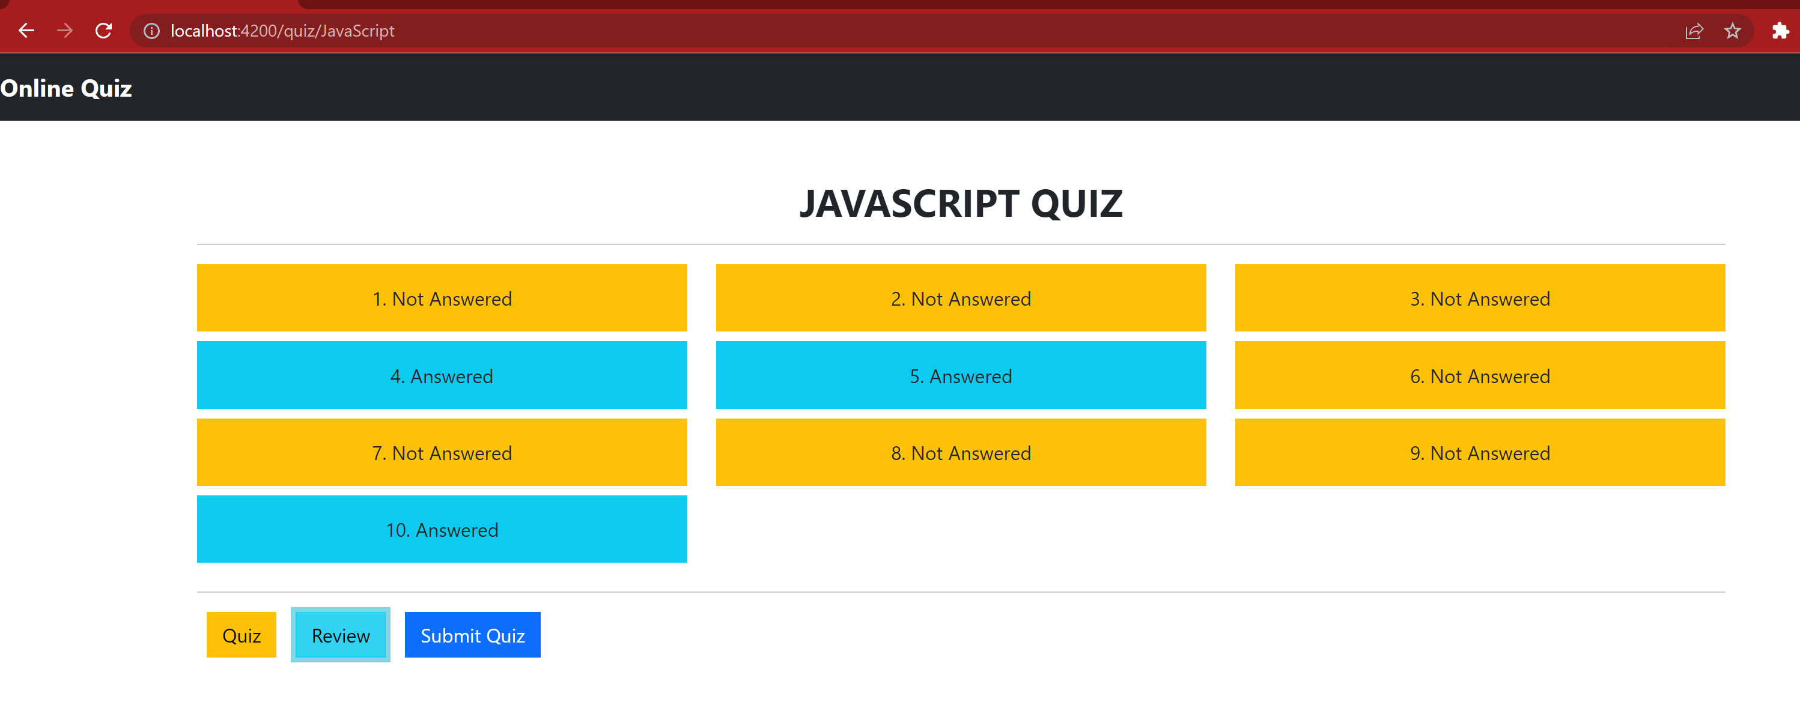

**When The user clicks on Submit button, they can see their result along with Questions and Options they have selected:**

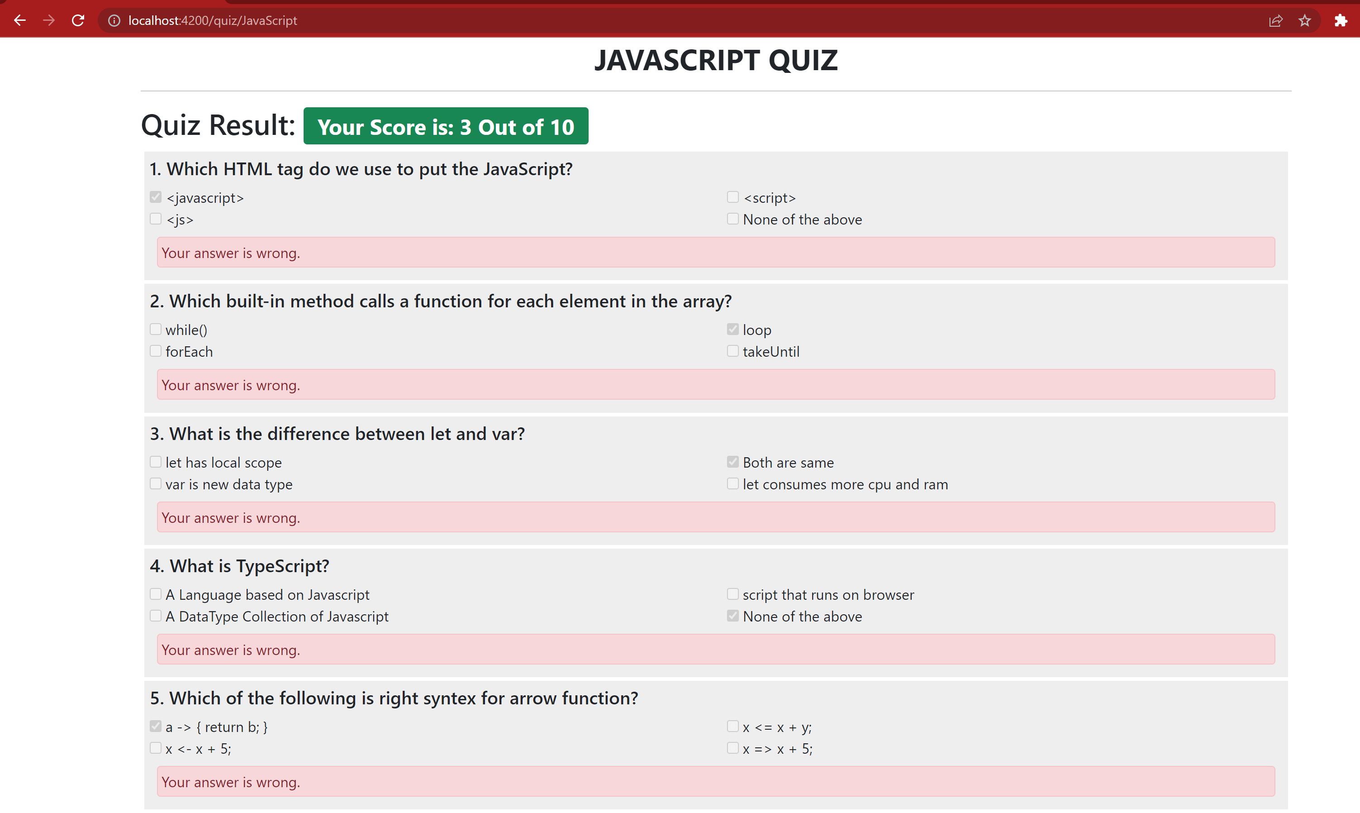

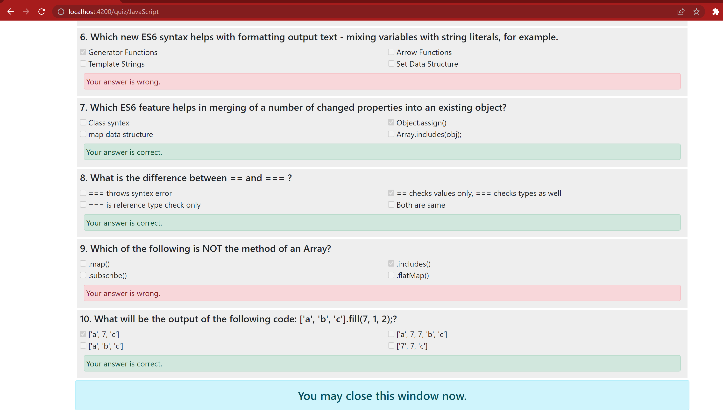

1. **User Selects to give Asp.Net Quiz**



**When User Selects Asp.Net Quiz, they are redirected to Asp.Net quiz page where they can see all the questions with their options rendered from JSON file.**

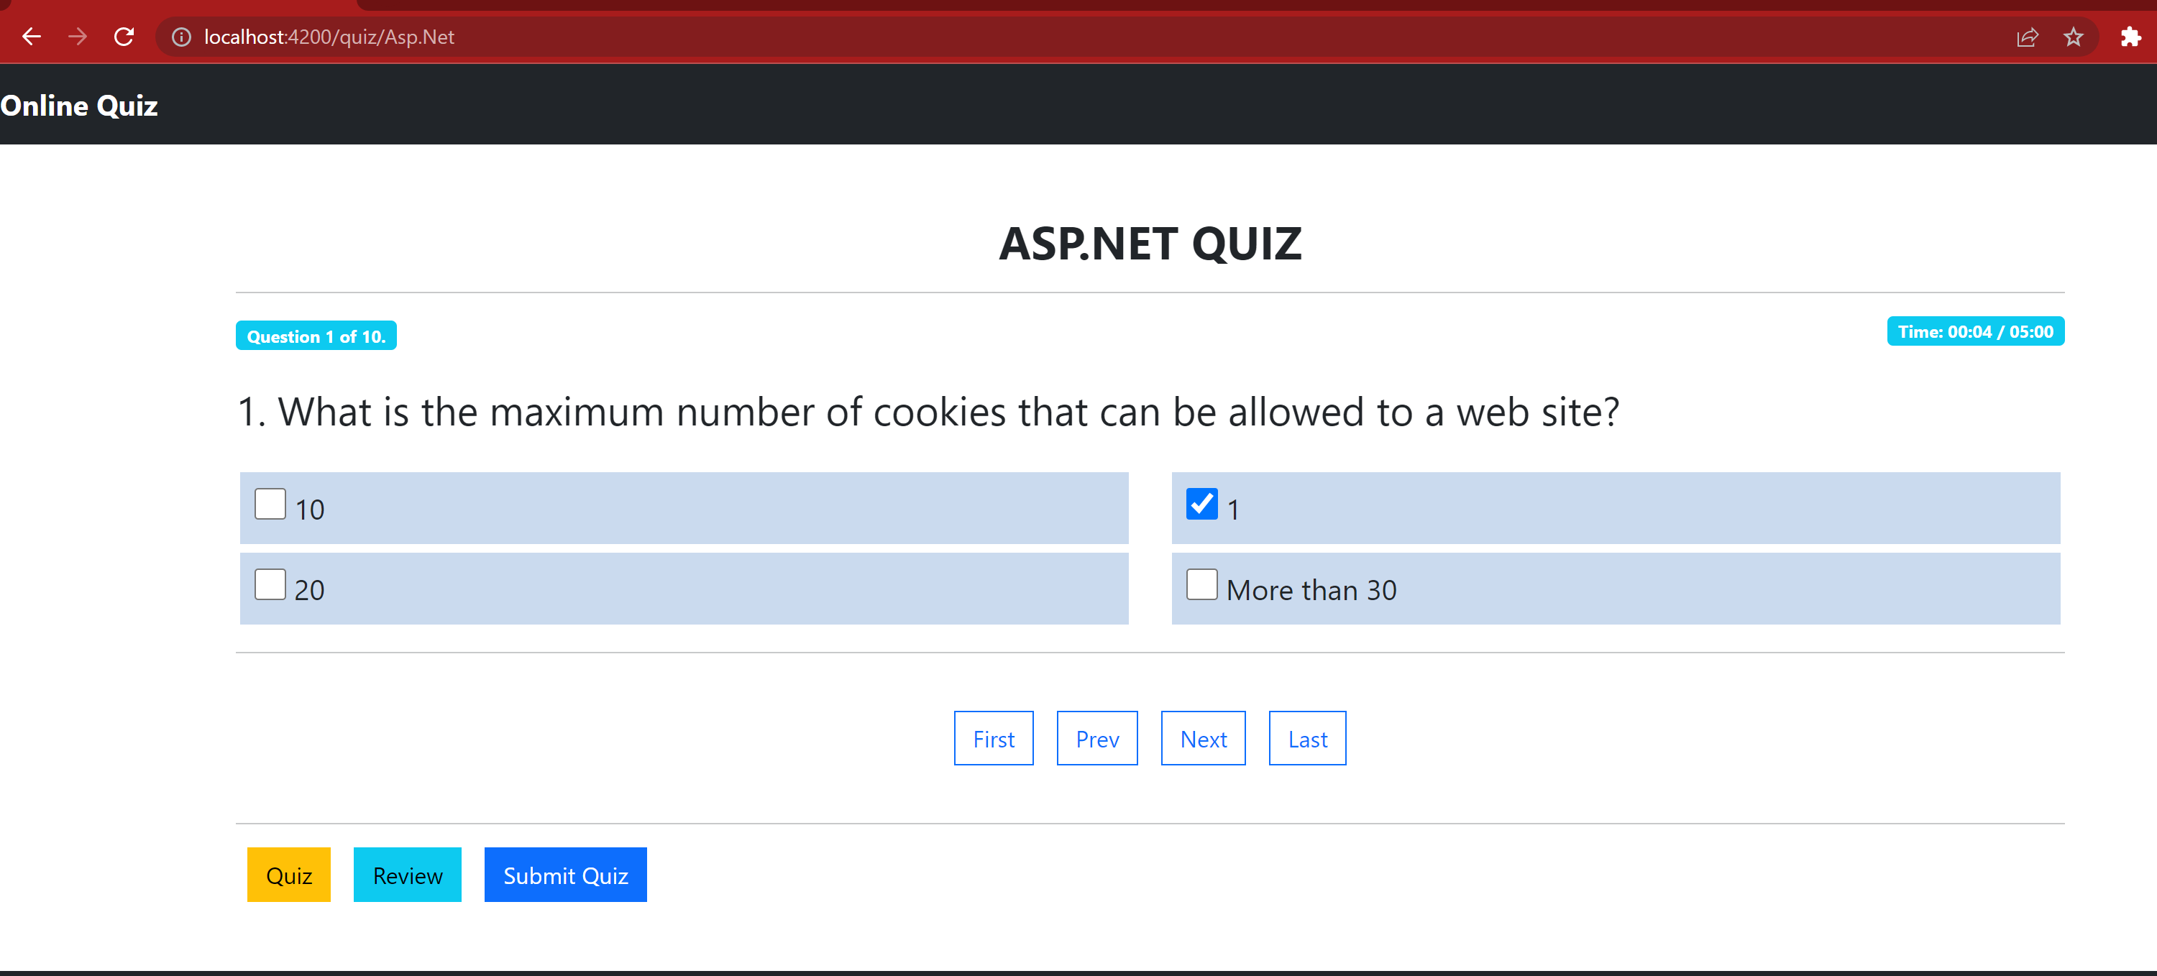

**User can select an option for the question and move to next question by clicking next navigation button**

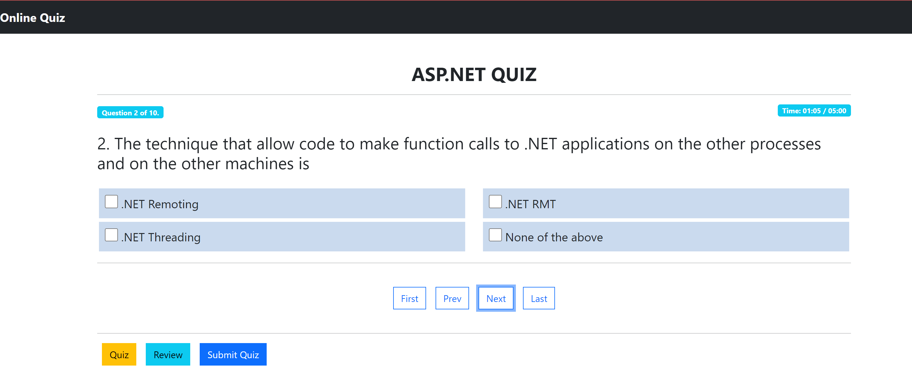 **Similarly, User can Answer all the questions asked**

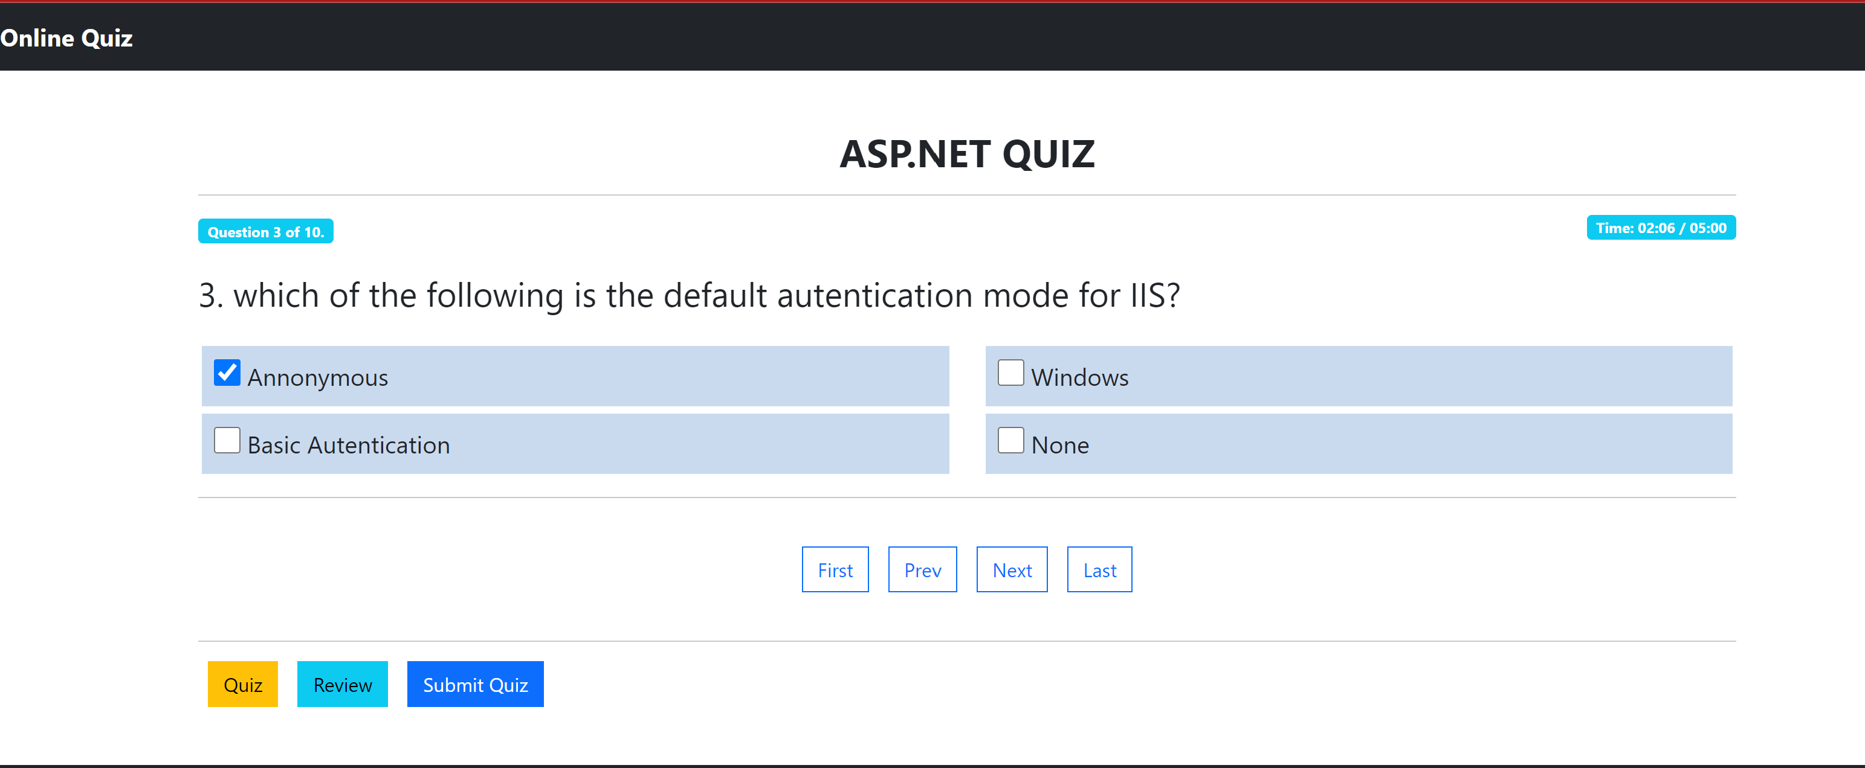

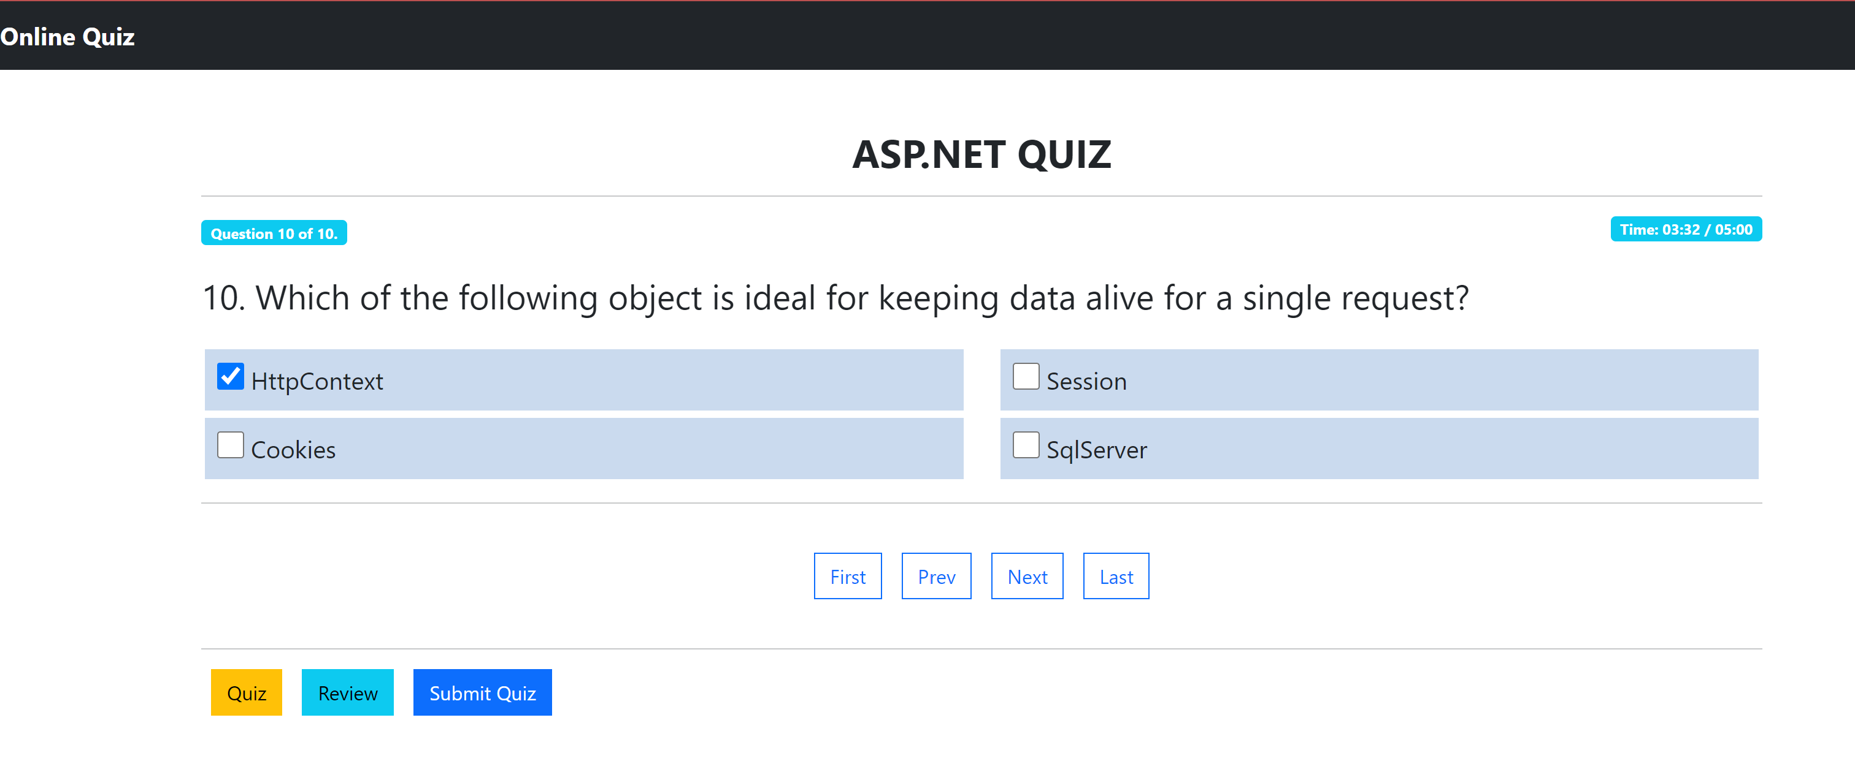

**Similarly, User can Answer all the questions asked**



**User can also navigate to last or First question directly from First and Last Nav Links**

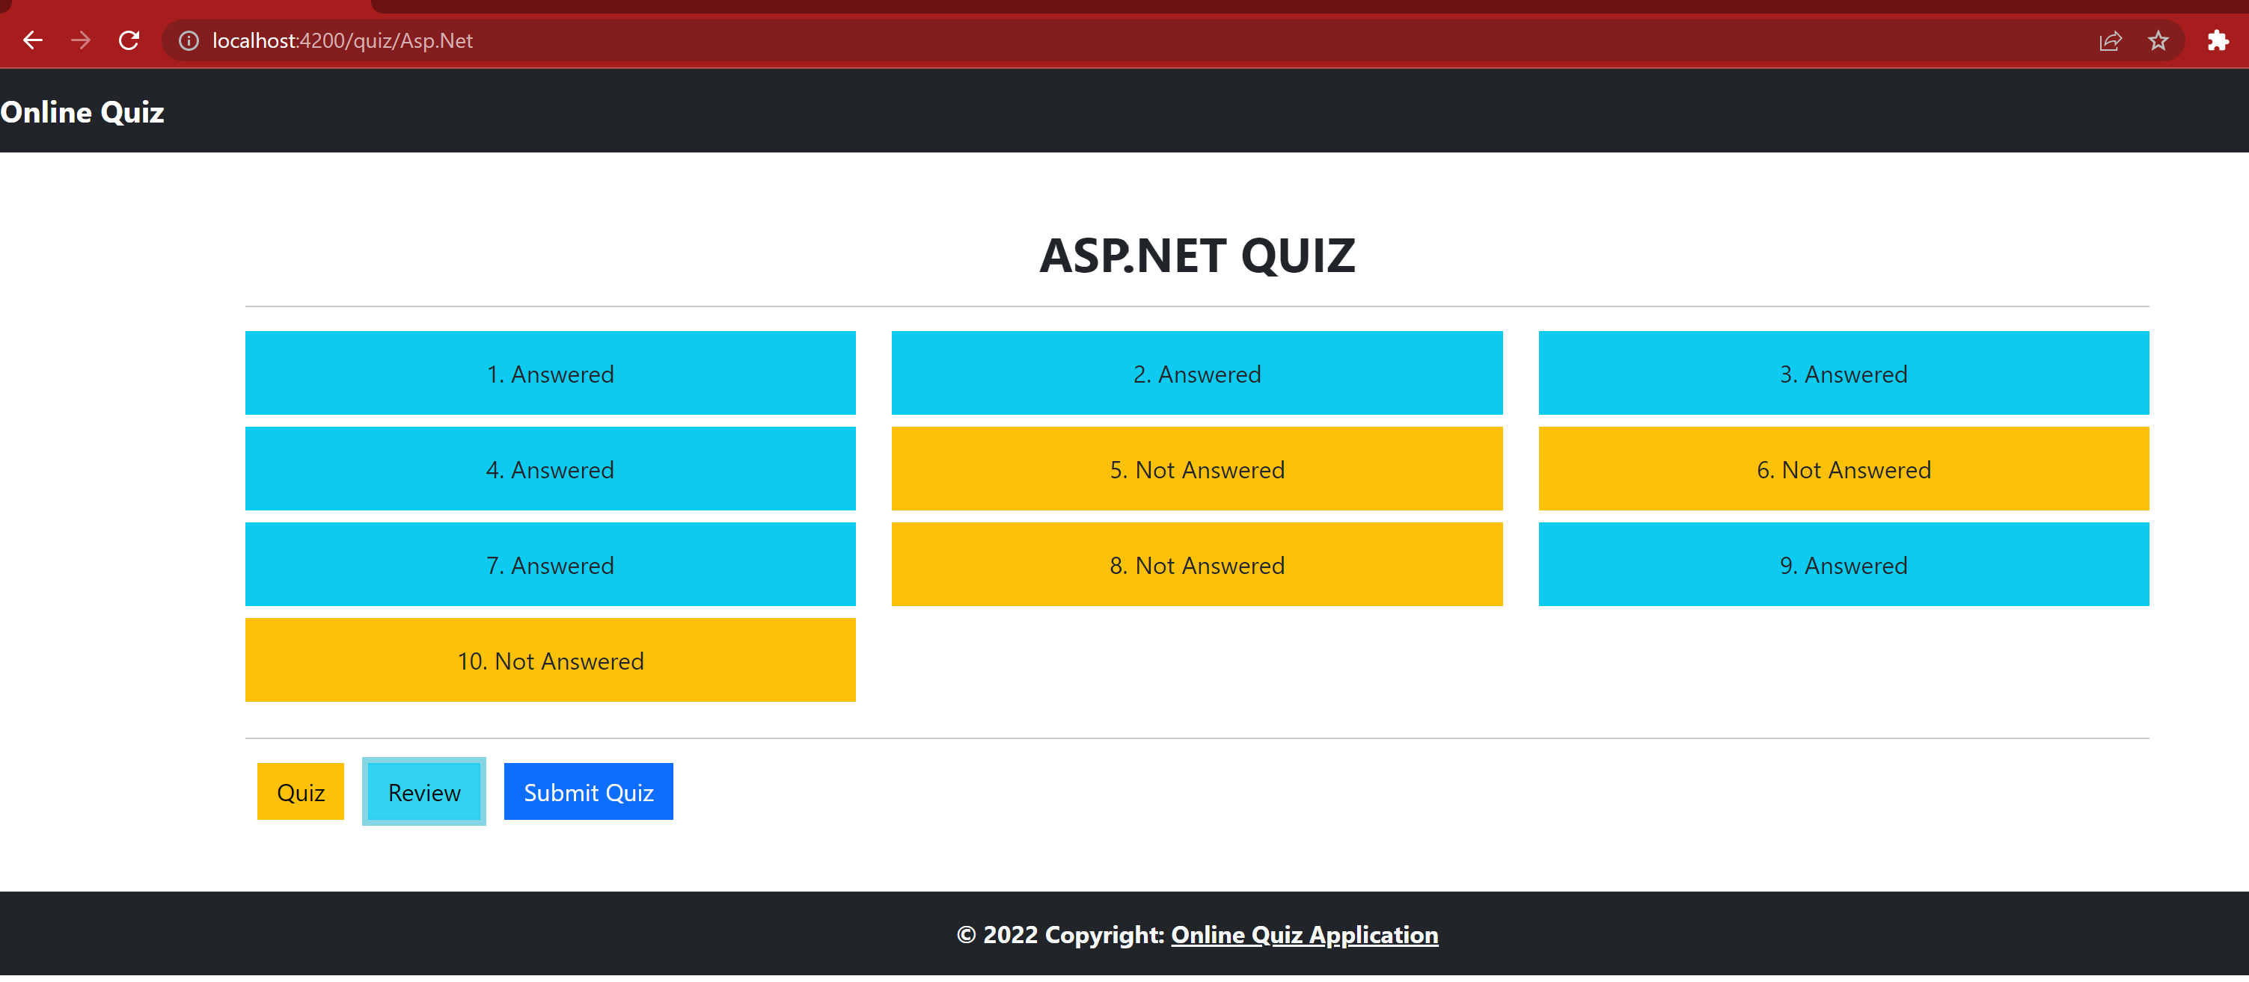

**User wanted to answer the 8th Not Answered Question:**

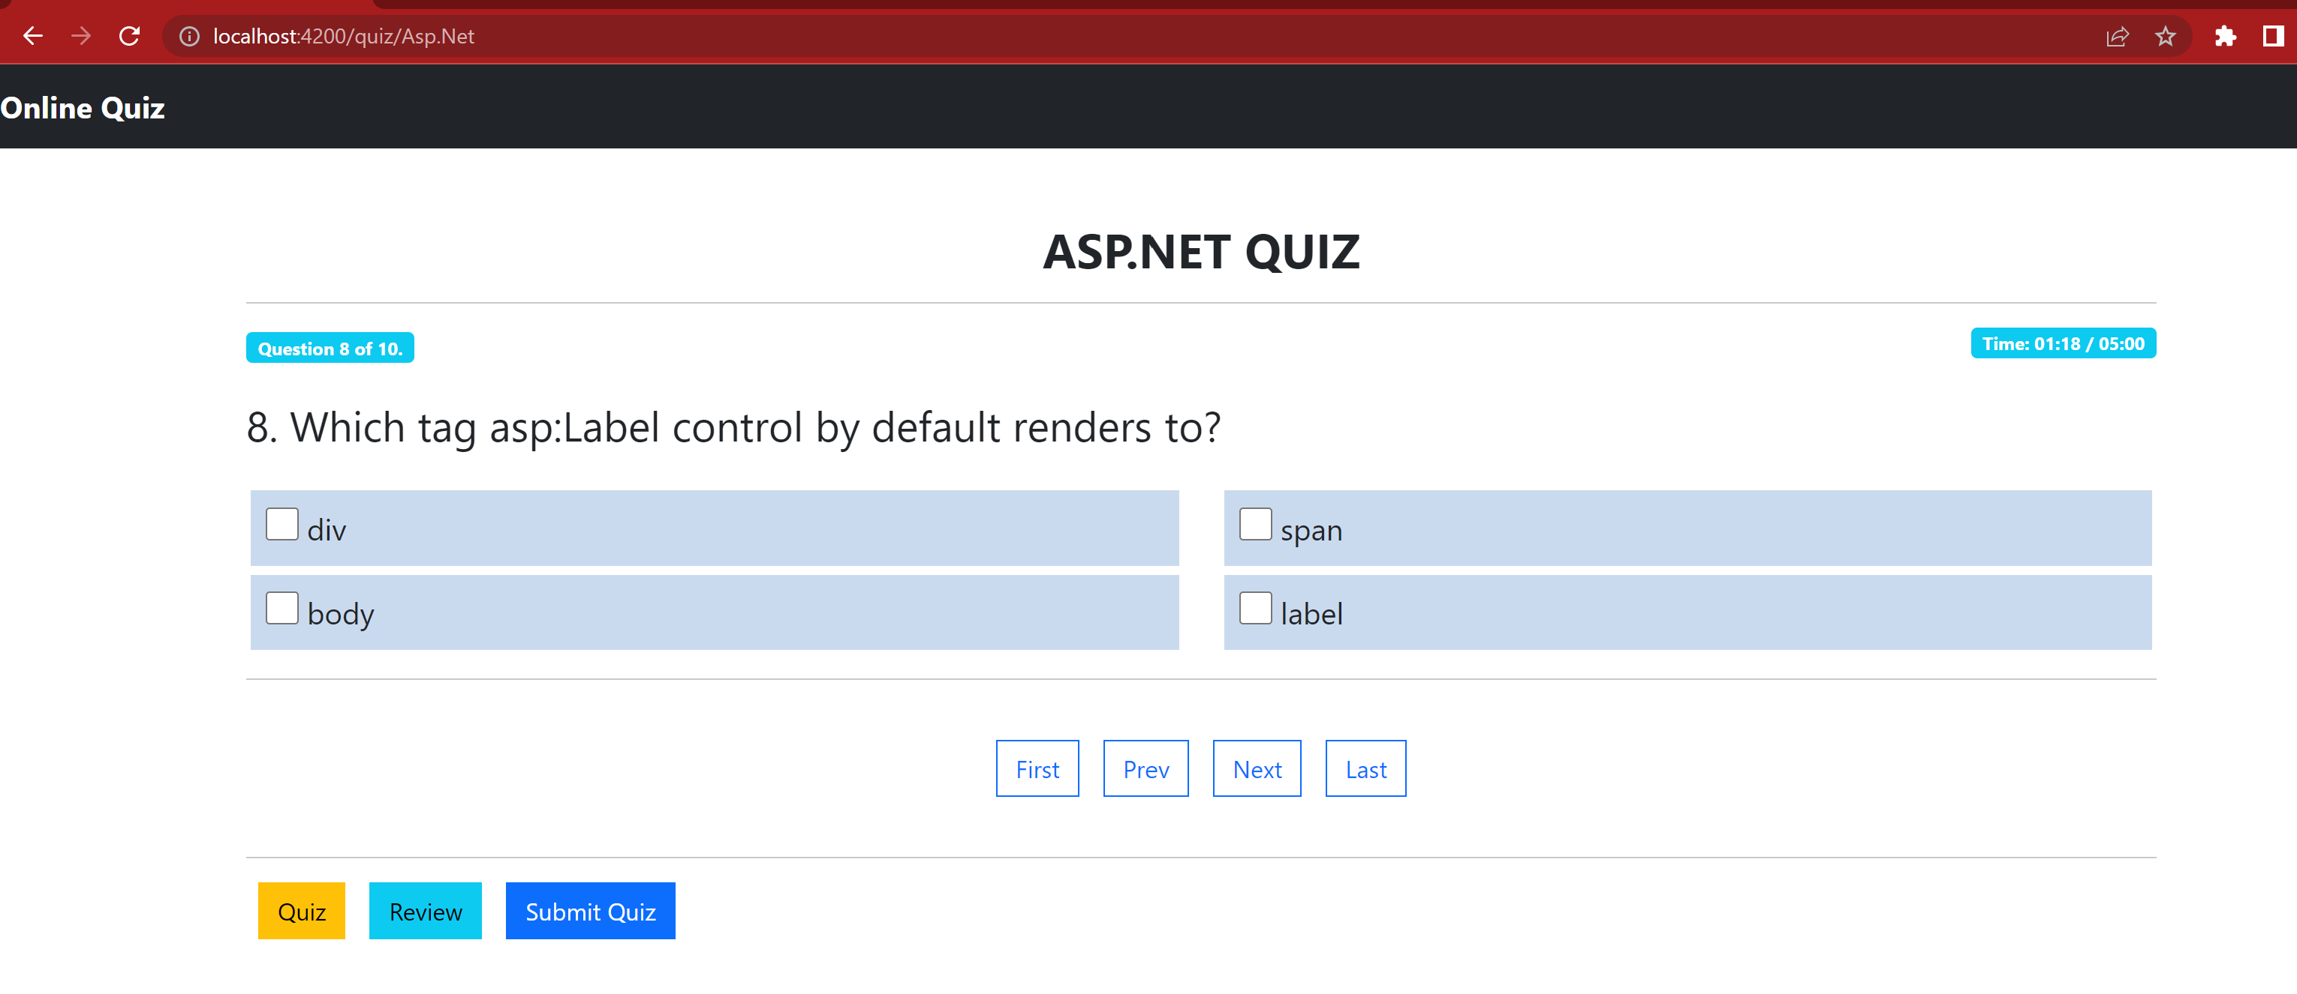

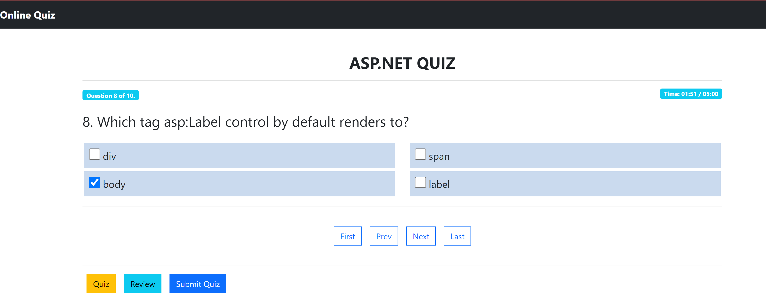

**8th  Question is Answered Now:**

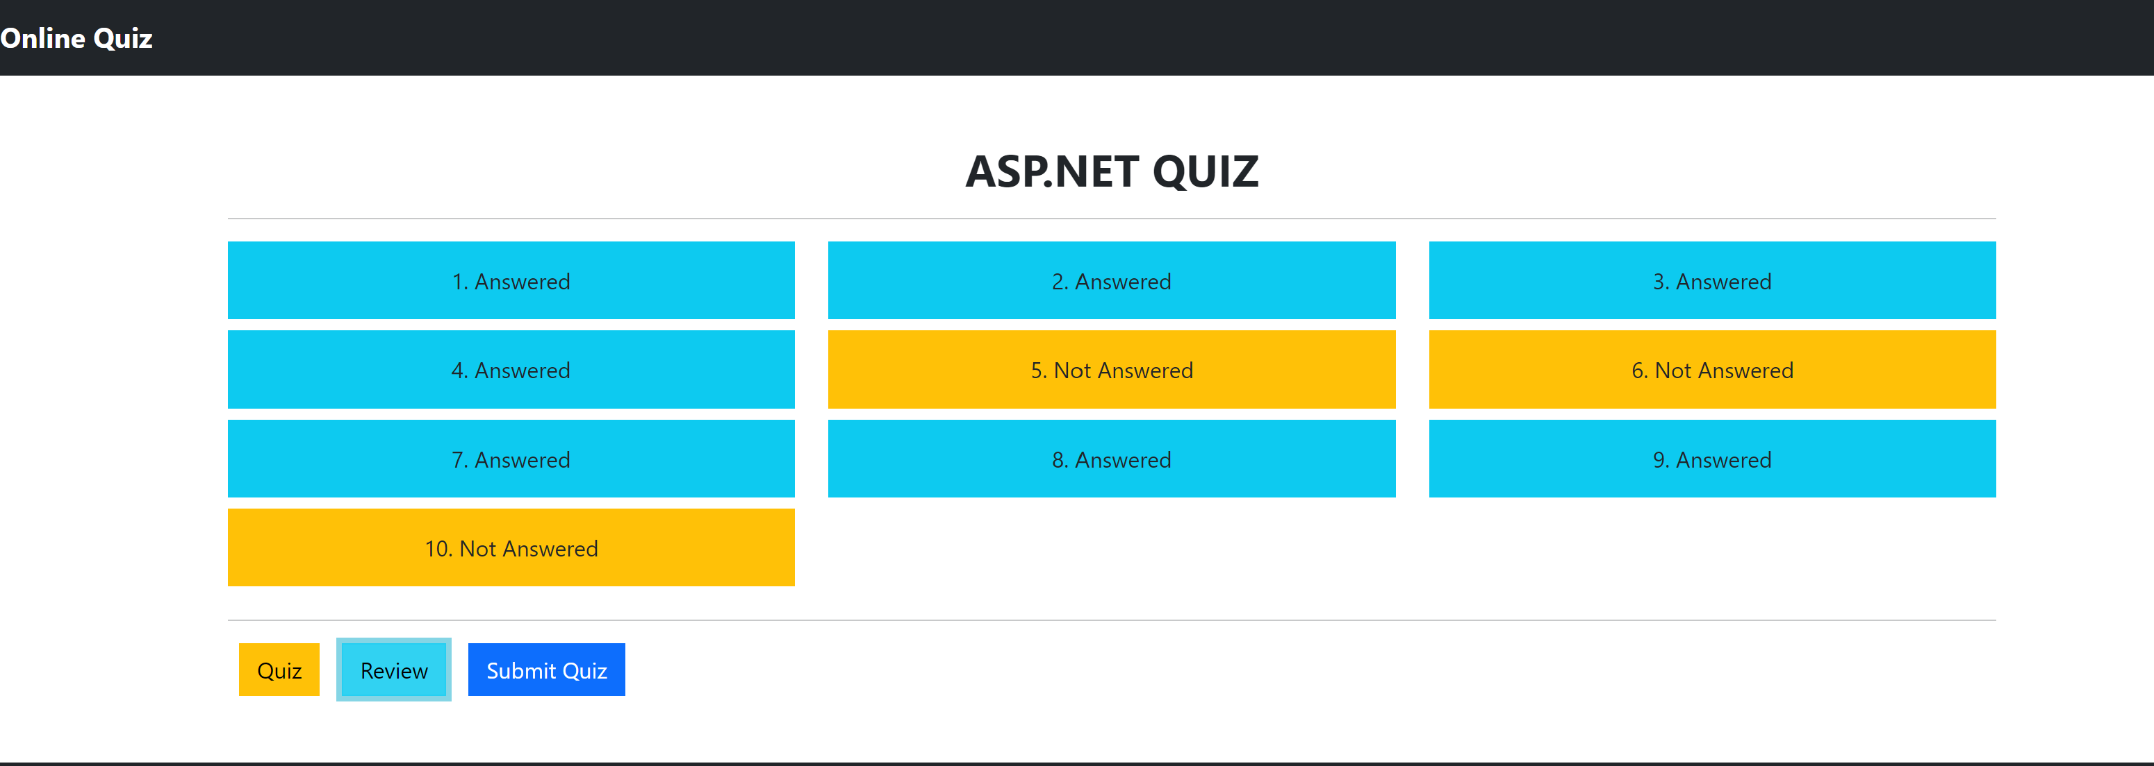

**When The user clicks on Submit button, they can see their result along with Questions and Options they have selected:**

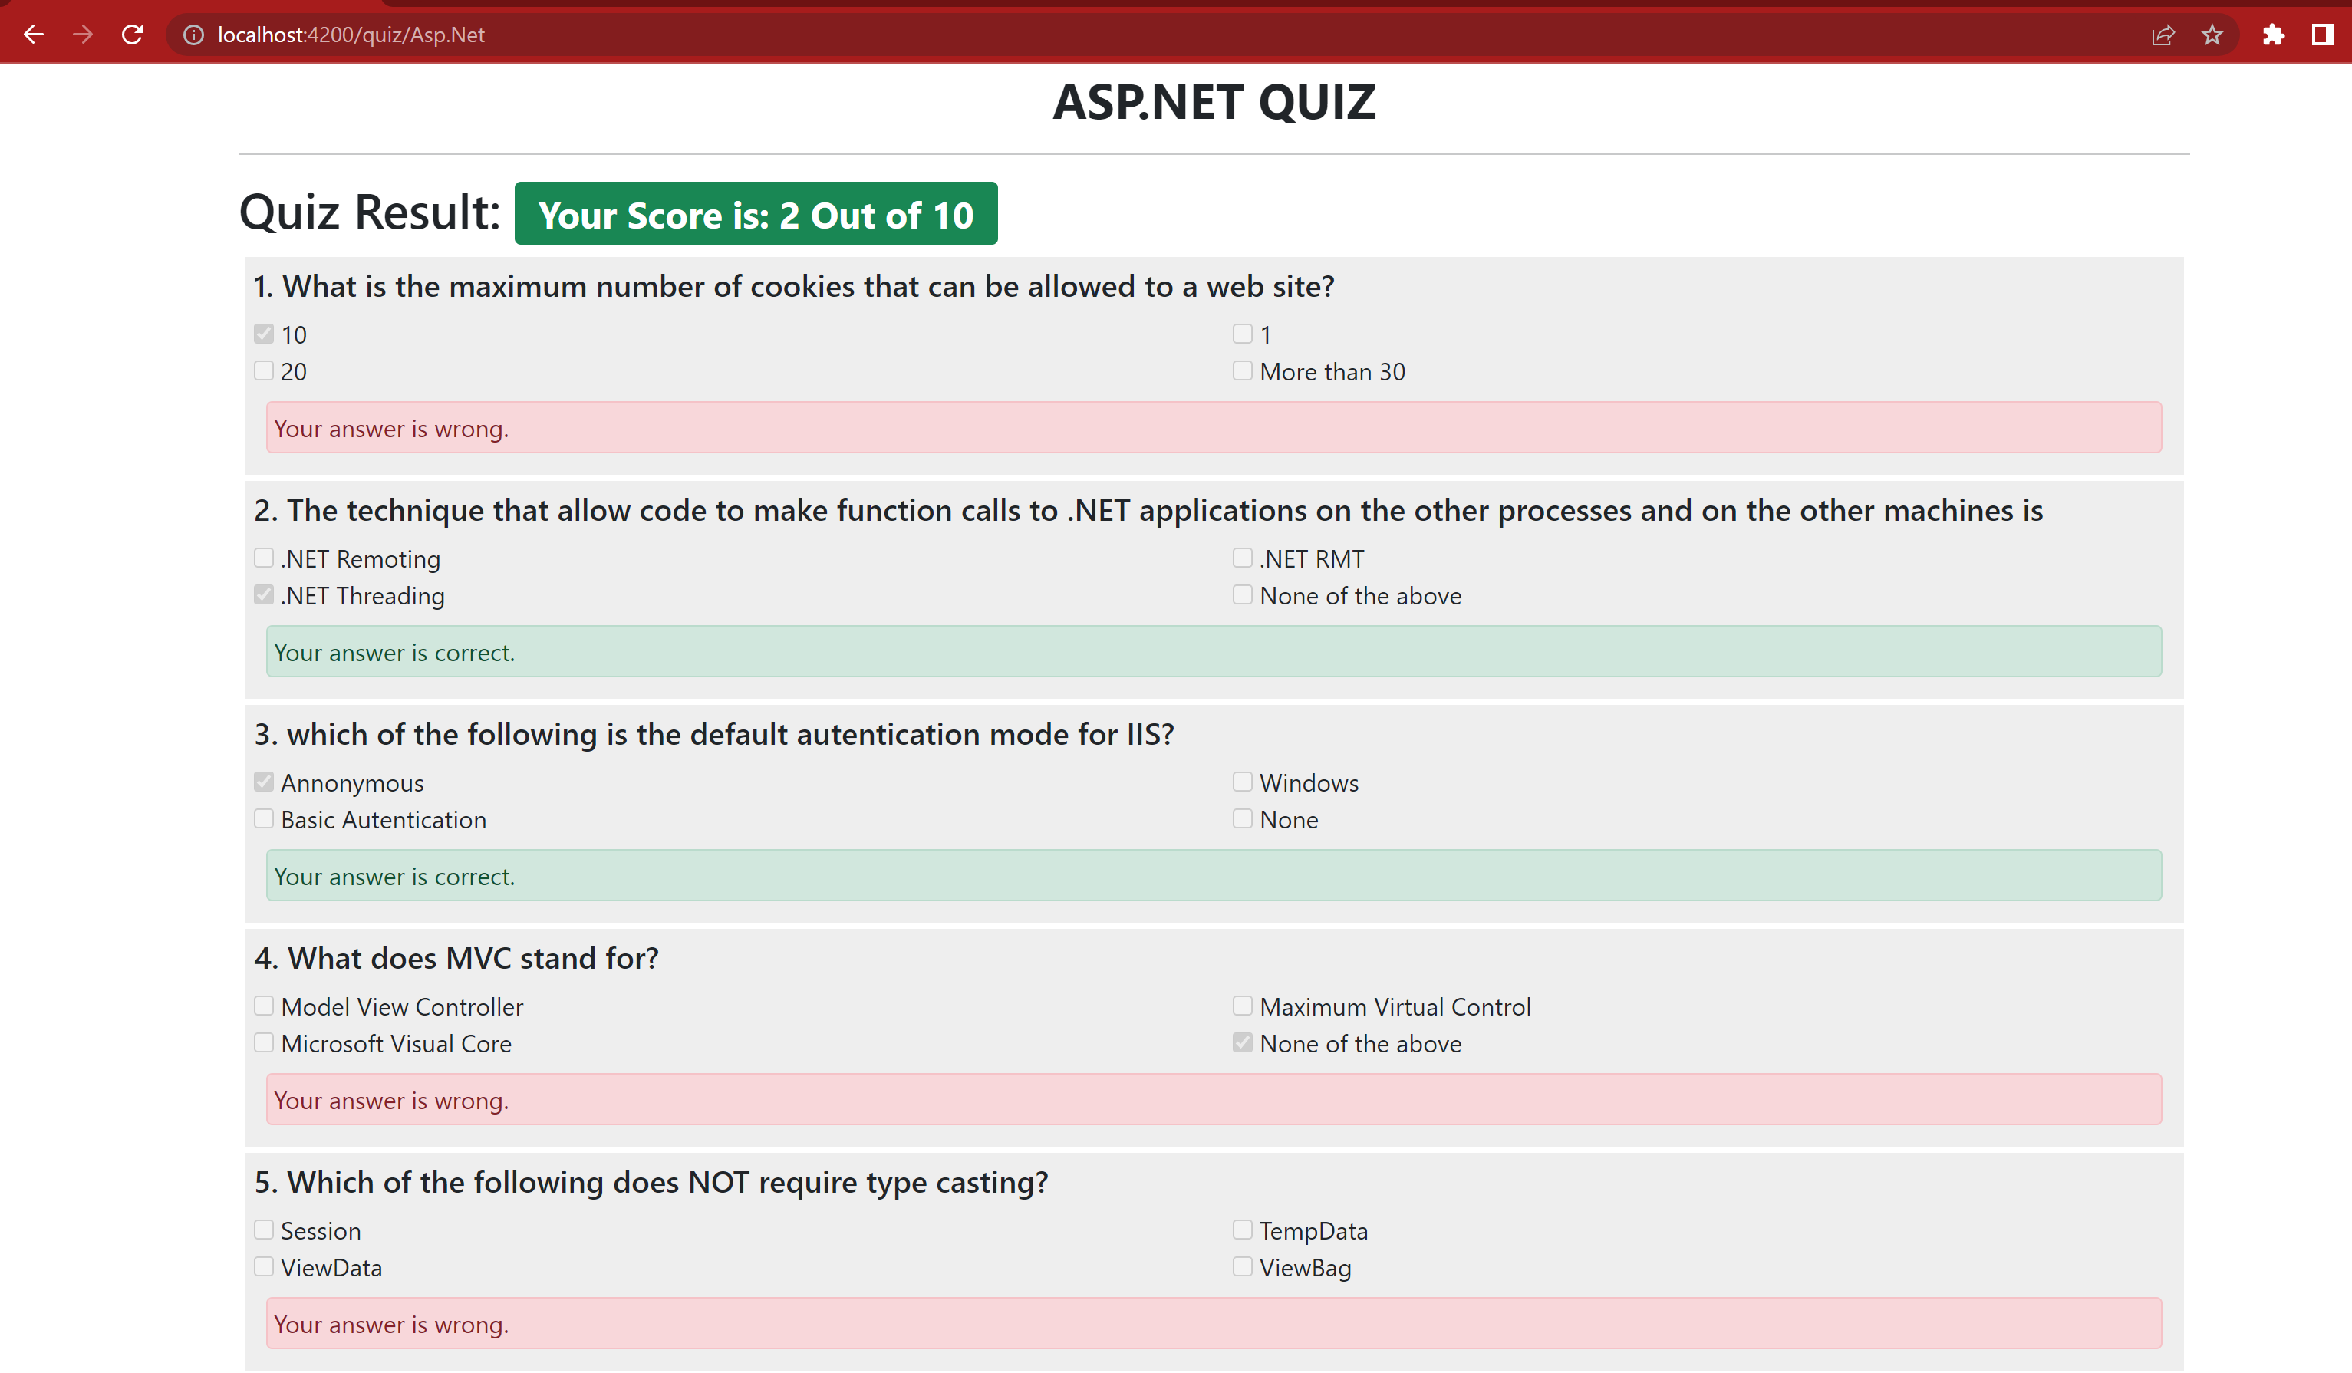

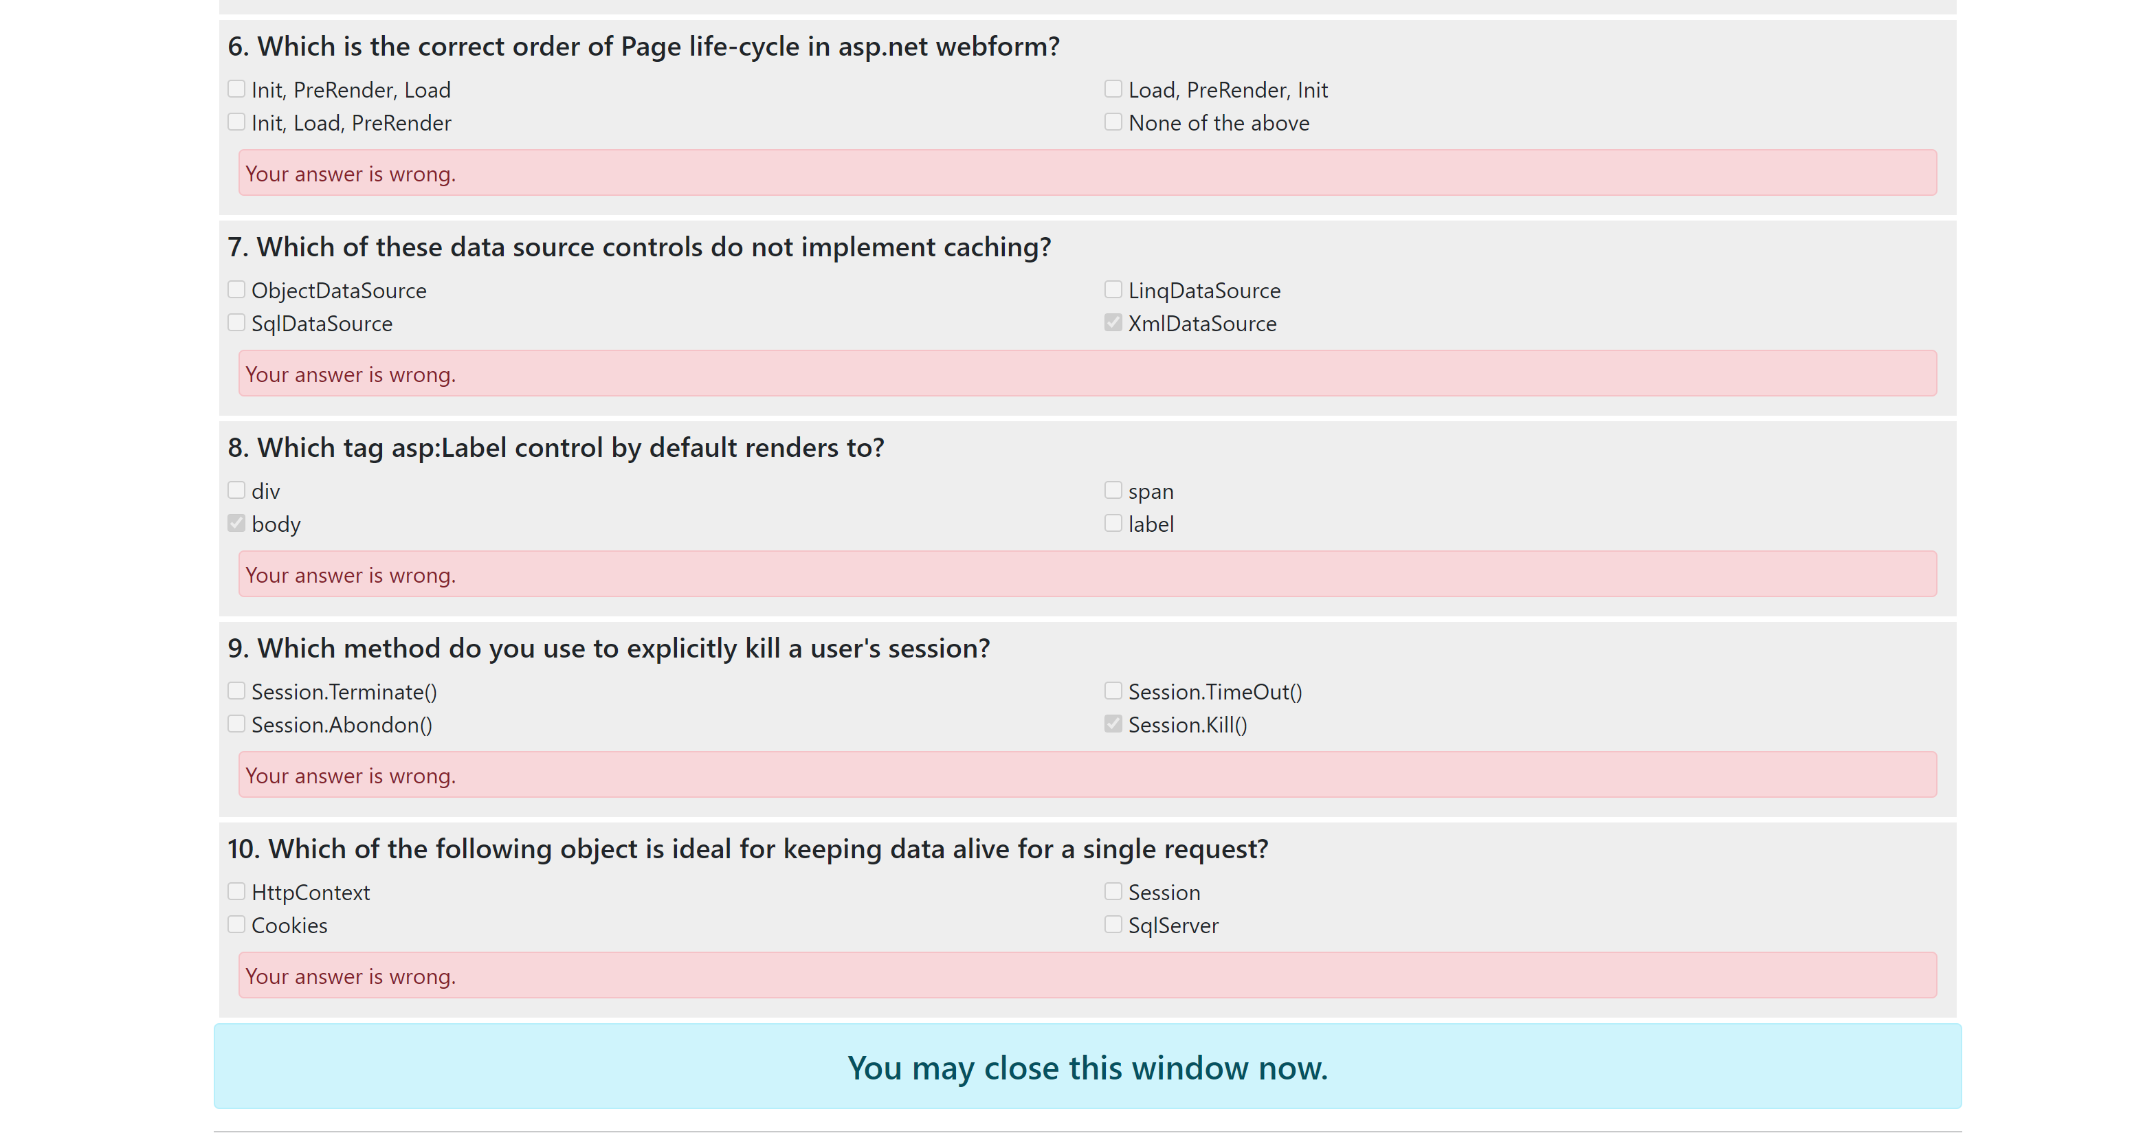

1. **User Selects to give C Sharp Quiz**





